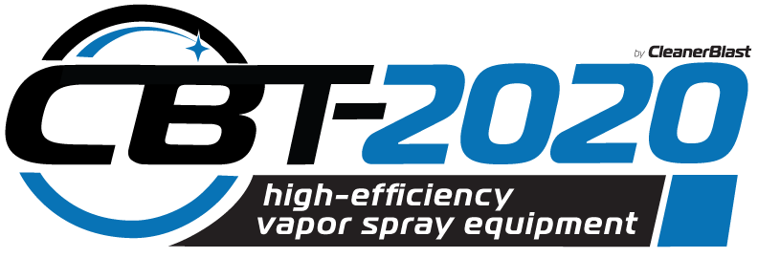

Case Study Ascension Parish LA: Administrative Building
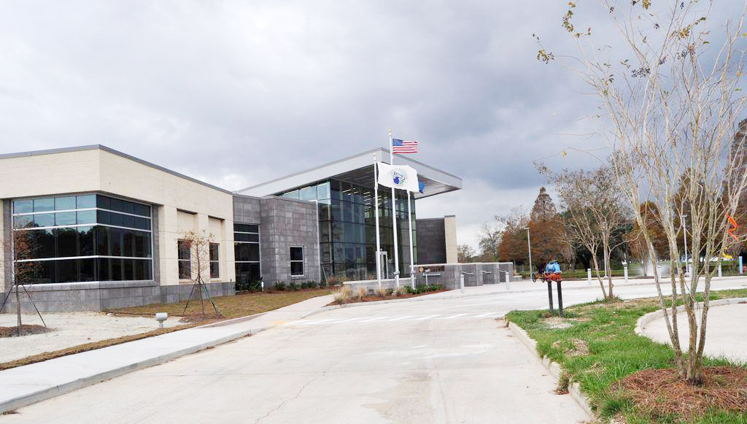
Equipment: One CleanerBlast CBT-2020 chemical sprayer
Location: 110,000 sq. ft.- Ascencion Parish Government – Entire Office Building
Surfaces: Furnishing, walls, window coverings, floors, restrooms, etc.
Total time to complete detailed disinfection: Requested by department head for COVID disinfection.
End-User Ratings (1-10):
Ease of use: 8
Efficiency: 9
Confidence in result: 8
Customer Endorsement: Cost Savings & Flexibility
“Big cost savings by taking it in-house. Previously, we were using outside vendor at a cost of $30,000 for entire facility. By taking it in-house we lowered cost and are able to address issues on our schedule, not an outside vendor.”.
– John Diaz, Chief Administrative Officer, Ascension Parish.

